Africa Academy of Management (AFAM) 2022 Webinar Series

Topic: Responsible Leadership and Management Practice for a Sustainable Africa

Date: Wednesday 21 September, 2022
Time: 13h00-14h30 (GMT);11h00-12h30(WAT); 08h00-09h30 (EST)

Registration: https://us02web.zoom.us/webinar/register/WN_Jb9gV-HrQPWoaDCk7eMYVw

Confirmed Panelists:
- Prof Edward Kieswetter, Commissioner at the South African Revenue Services
- Prof. Kenneth Amaeshi, Chair in Sustainable Finance and Governance European University Institute, Florence, Italy

Moderator:
Dr. Natasha Winkler-Titus, Stellenbosch Business School, South Africa

Africa is at a crossroads. A more sustainable and equitable Africa urgently requires new leadership models that put responsibility, accountability, and sustainability at the heart of its institutions, be they private or public. The concept of responsible leadership has been the subject of academic and practitioner conversations in the last two decades. The idea is that the influencing power of leadership should reach beyond a single organisation toward improving society and the world. But it appears to be deeper than just a role; rather it represents a form of agency that gives meaning to what is responsible and possible, a form of conditioning role, of shared and nested concerns toward the greater good. A key component of the responsible leadership competencies includes doing, and thus implying process and practices as a consequence of responsible leadership.

The AFAM Webinar series brings together experts to illuminate the positions around a set topic and invite active engagement toward scholarship, governance, and practice. The key issues/questions we will address in this webinar include:
- What is the voice of businesses, management education and governing bodies in responsible leadership and practice?
- How can businesses, management education and governing bodies partner towards responsible leadership and management practice?
- How can businesses, management education and governing bodies scale their reach and impact toward responsible leadership and practice?

The Round table discussion serves as primer to start the conversation that will be continued at the 6th Biennial conference of the Africa Academy of Management, January 8-10, 2023 at the German University in Cairo, with the theme: Management Praxis in the African context- Sustainability, Responsibility and Ethics.

Webinar Series Organisers:
Prof. Judy N. Muthuri, Nottingham University Business School, UK
Dr. Franklin Nakpodia, Durham University Business School, UK
Prof. Amanuel Tekleab, Wayne State University, USA
Dr. Natasha Winkler-Titus, Stellenbosch Business School, South Africa

Panelists Profiles:

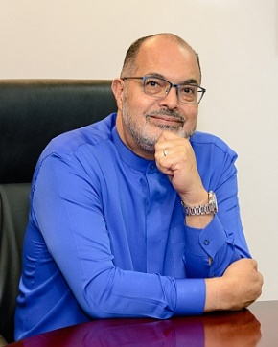
Edward Kieswetter is the Commissioner at the South African Revenue Services (SARS) which he re-joined on 1 May 2019. He had formerly served as the founding Group Executive of the SARS Large Business Centre and High Nett Worth Unit, SARS Chief Operating Officer and Deputy Commissioner during the period 2004 to 2009. From 2010 to 2016, he was the Group Chief Executive for the Alexander Forbes Group Holdings where after a successful turnaround, the company was listed on the JSE. Edward also held senior executive roles at FirstRand Banking Group and Eskom. Most recently he managed his own investments and served on various boards which amongst others included NE: Transnet, Chair: Technology Innovation Agency and Lead Independent: Shoprite Holdings. Edward is the recipient of several awards including a Lifetime Achievement Award for Excellence in Management in 2017 from SAPSO, Finalist in the All Africa Business Awards 2016, ACO Dealmaker of the Year, 2015, and SA Boss of the Year, 1999. He serves as a Visiting Professor at the Da Vinci Institute as well as Free State University, Member of Ahmed Kathrada Foundation and remains involved as a Social Activist.

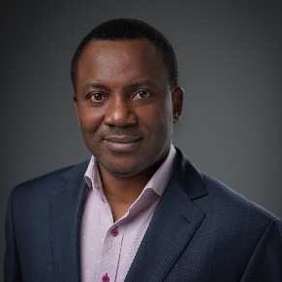
Kenneth Amaeshi is a Professor of Sustainable Finance and Governance at the School of Transnational Governance. He is currently on leave from the University of Edinburgh, where he is the Chair in Business and Sustainable Development and Director Scaling Business in Africa. Kenneth is a leading scholar on sustainable business and finance in the global south. His research interest currently focuses on financial market reforms and governance, as well as on sector-level policies for sustainability and sustainability strategy in organisations. He has an expert level knowledge of developing and emerging economies. His research has a very strong interface between business and society, particularly national governments in Africa, where he has an extensive network. Since 2015, he has significantly contributed to developing the intellectual foundations of Africapitalism – an economic philosophy for the development of Africa – and championed its mainstreaming in the global academia. Besides teaching and researching, Kenneth works closely with businesses and governments in Africa, Europe, and Asia. He leads executive capacity building engagements and consultancy projects in the broad areas of sustainable finance, sustainability strategy, leadership, ethics, and governance for multinational corporations and institutions. Between 2016 and 2017, he was a Scholar in Residence at the National Pension Commission, Nigeria.

